----------

URL : http://demo.guru99.com/test/drag_drop.html

NOTE: Drag and drop bank in Account ,5000 in amount at debited side

Drag and drop sales in Account ,5000 in amount at credited side

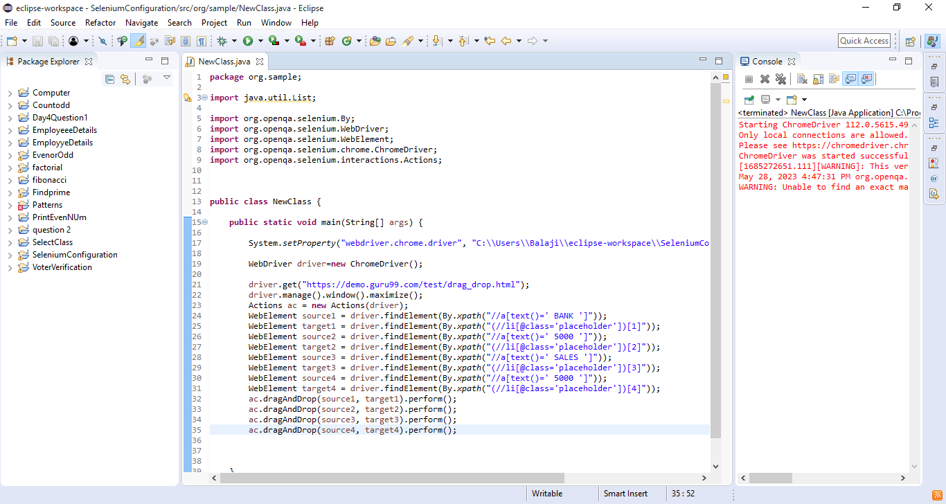

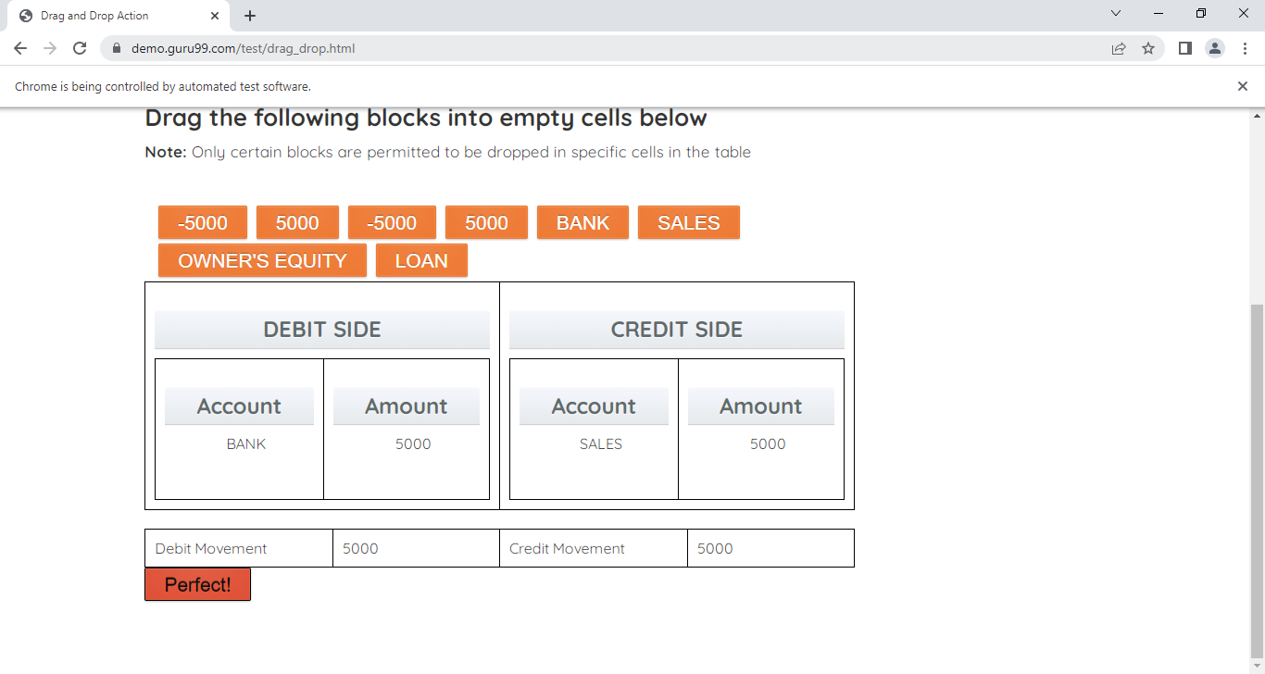

----------

URL : http://www.flipkart.com

NOTE: Home & Furniture is first mouseover

Click Bath Towels and print any product name

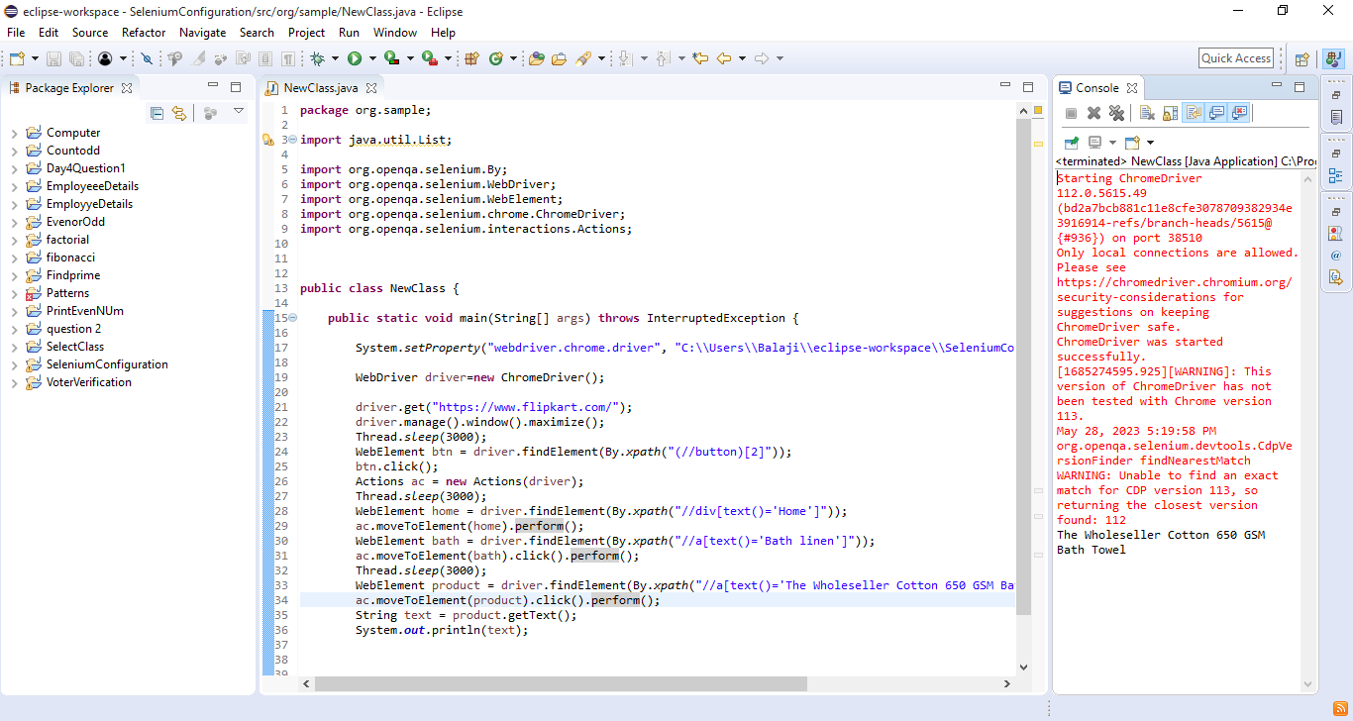

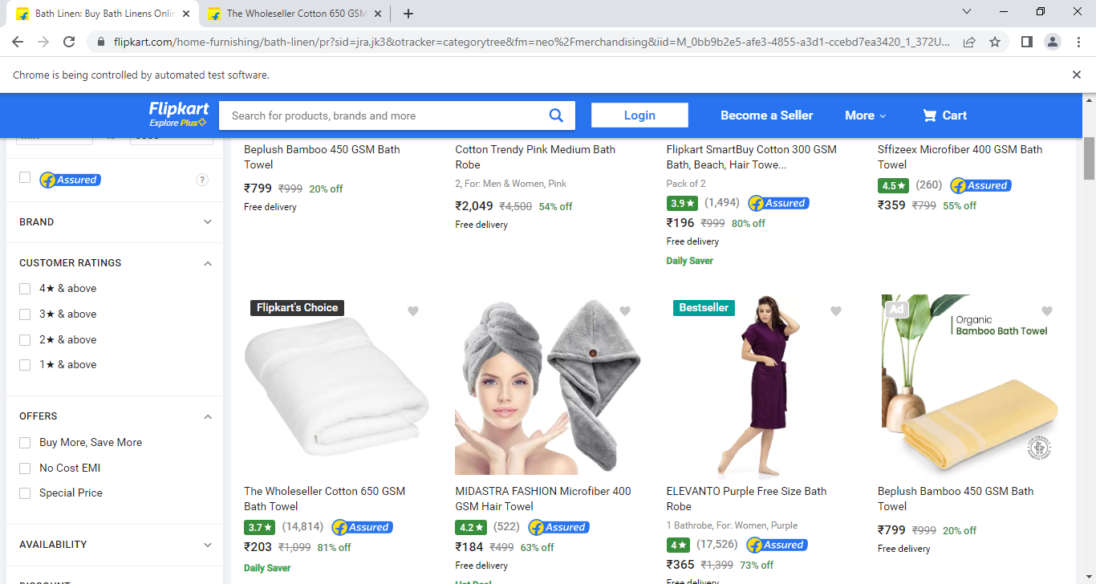

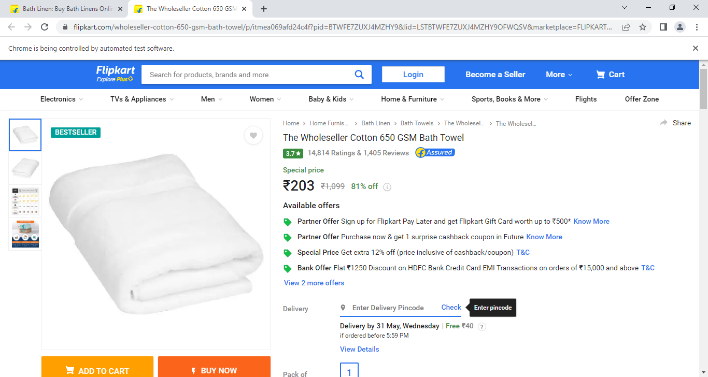

----------

URL : https://www.shopclues.com/wholesale.html

NOTE: Mobile and electronics is first mouseover

Click Smart Phones range Rs5001 - Rs10000

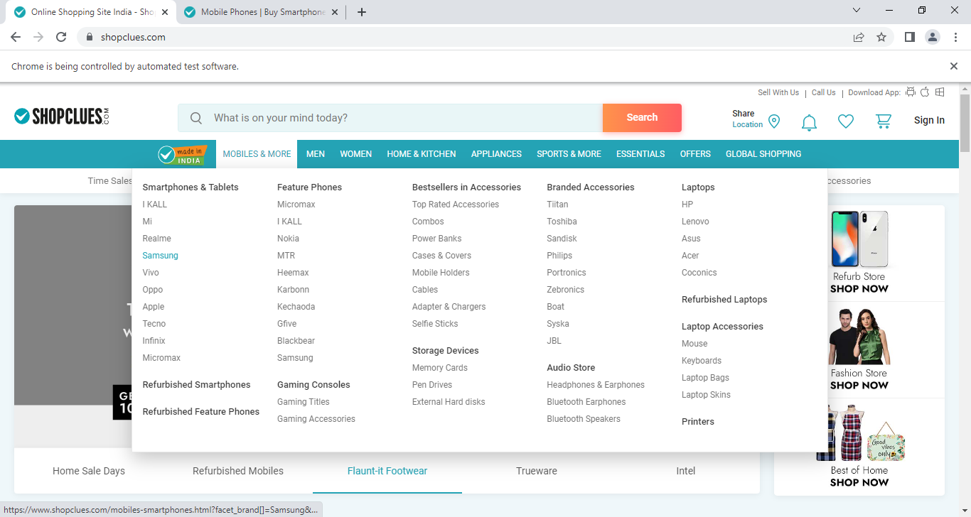

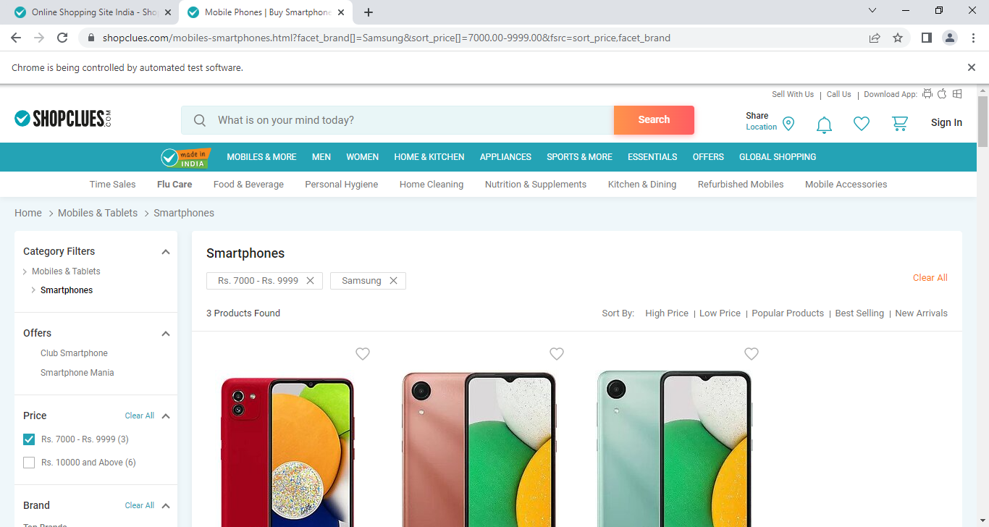

----------

URL : http://greenstech.in/selenium-course-content.html

NOTE: Course is first mouseover

Software testing training is second mouseover

Click selenium training

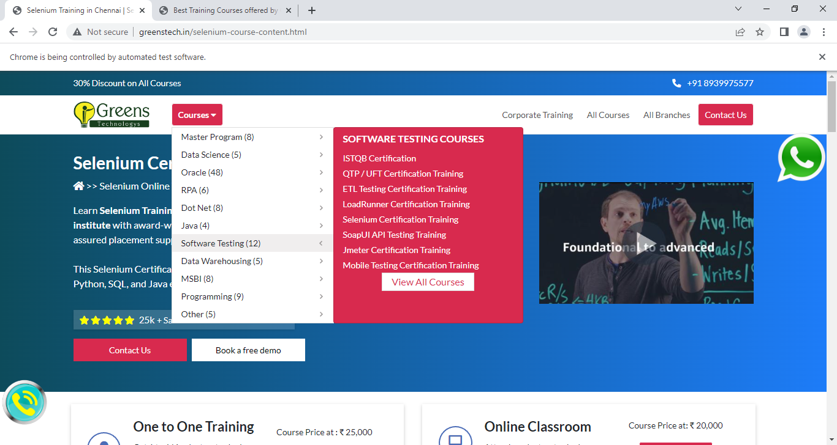 

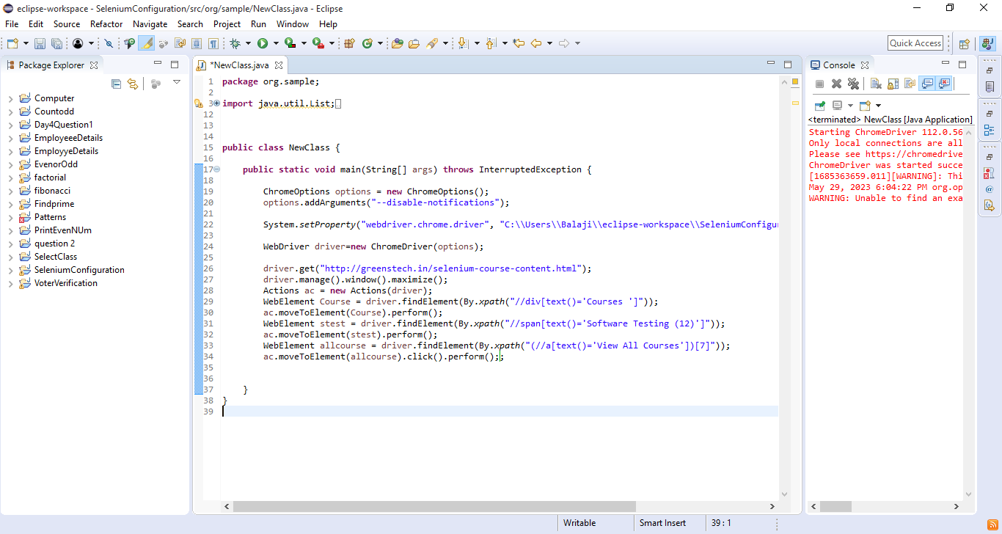

-----------

URL : http://greenstech.in/selenium-course-content.html

NOTE: Courses is first mouseover

Oracle training is second mouseover

Click Oracle sql training

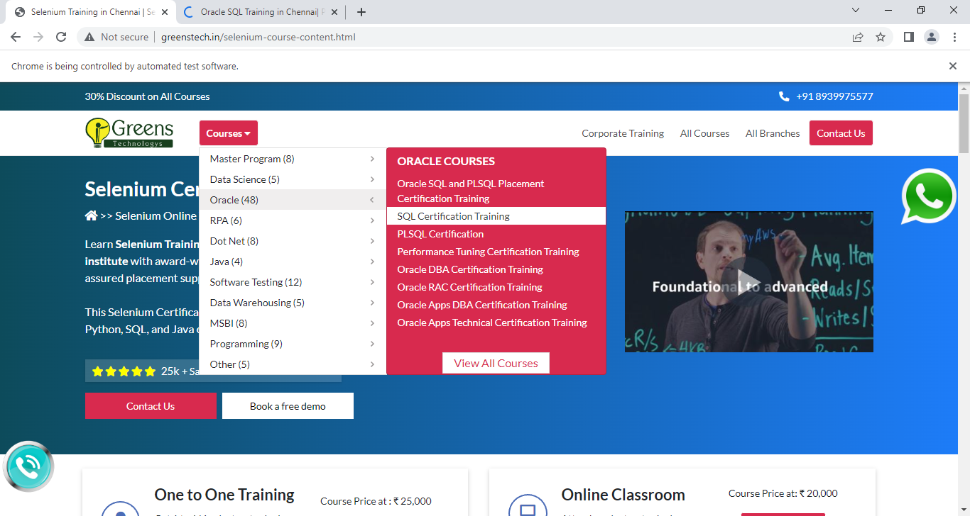

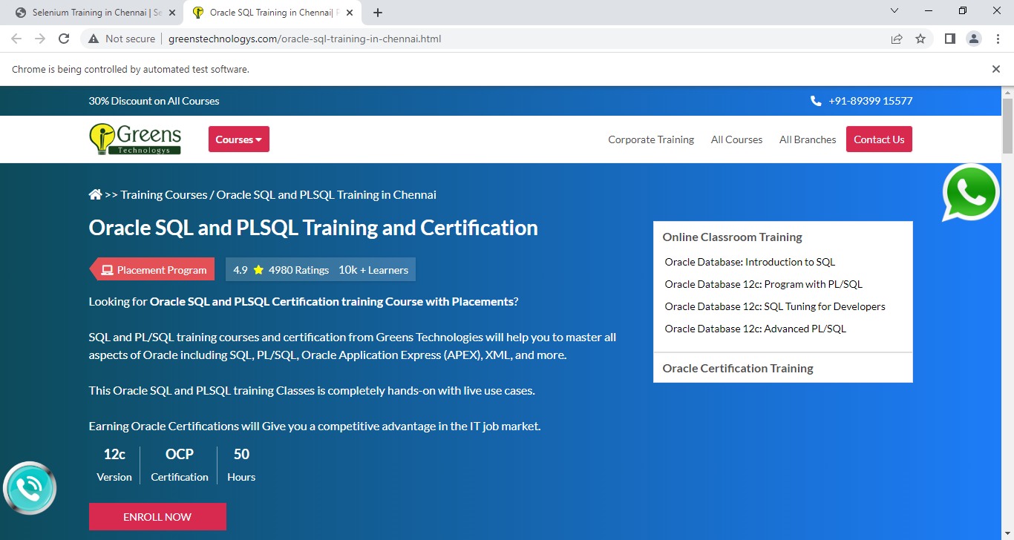

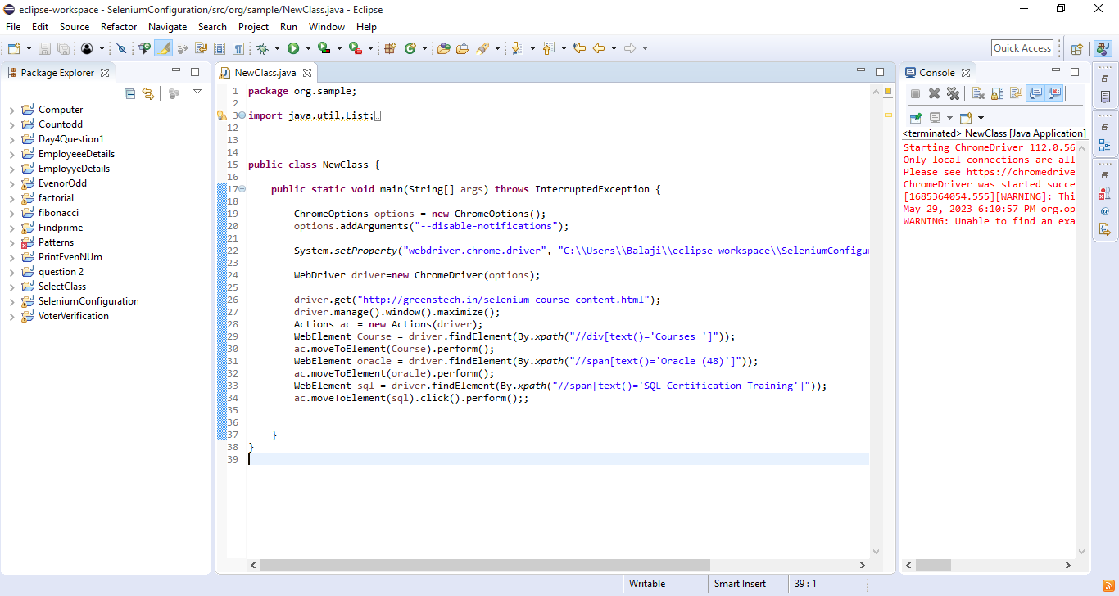

-----------

URL : http://greenstech.in/selenium-course-content.html

NOTE: Courses is first mouseover

Data Warehousing is second mouseover

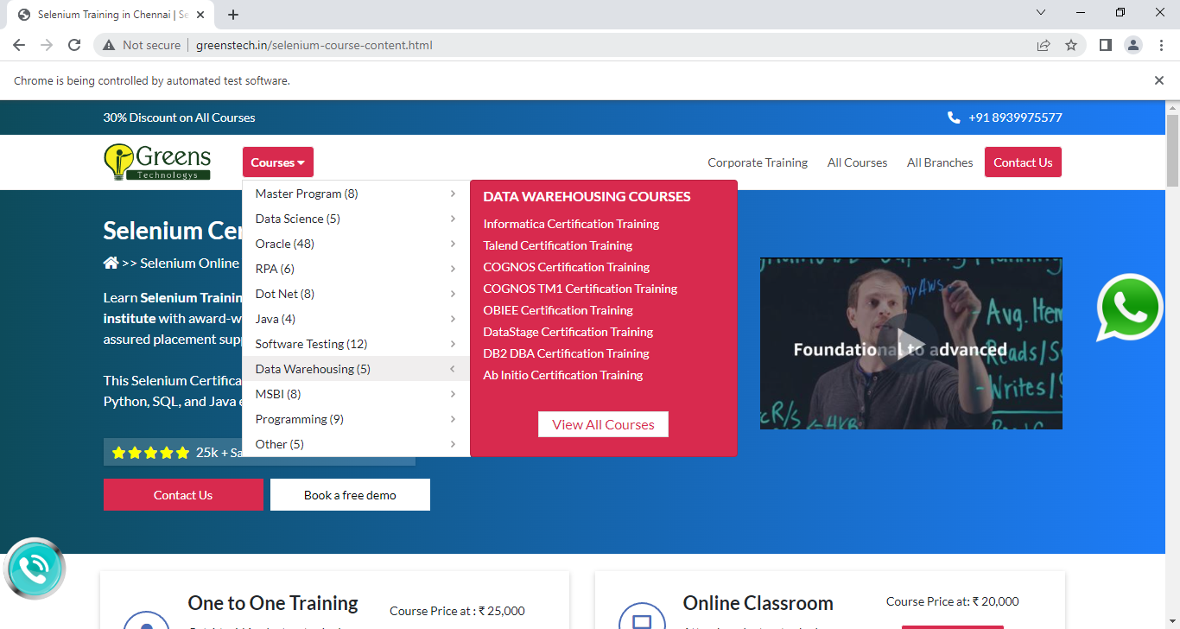

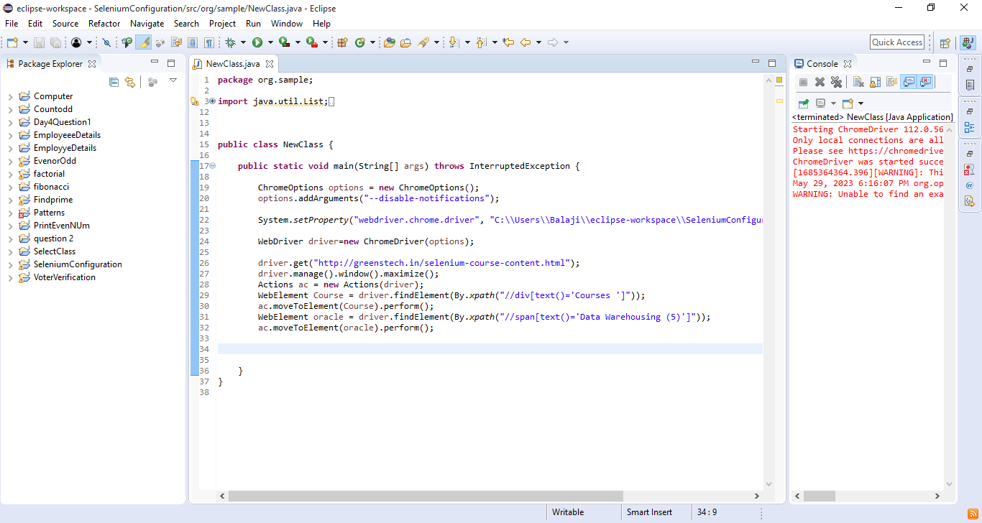

QUESTION 15

-----------

URL : https://www.amazon.in/

NOTE: Signin is first mouseover

Click Register

Give details for Register

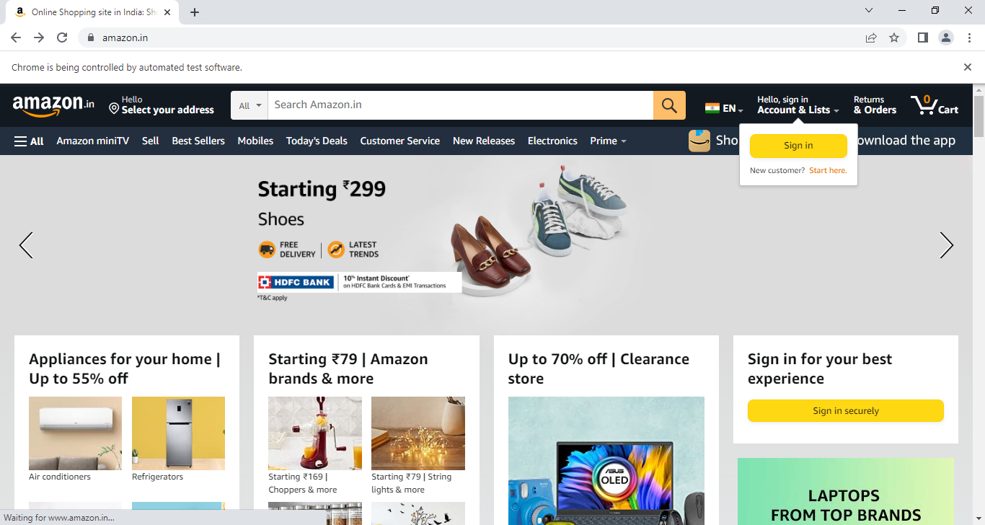

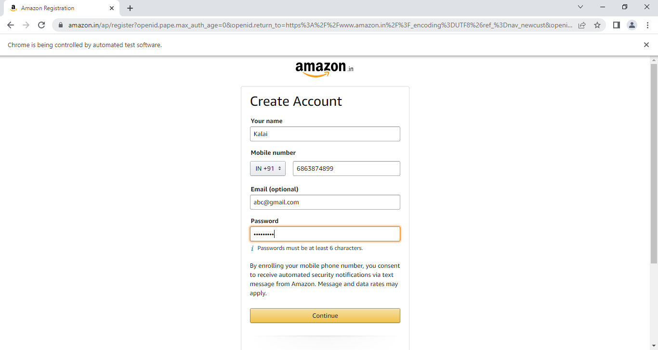

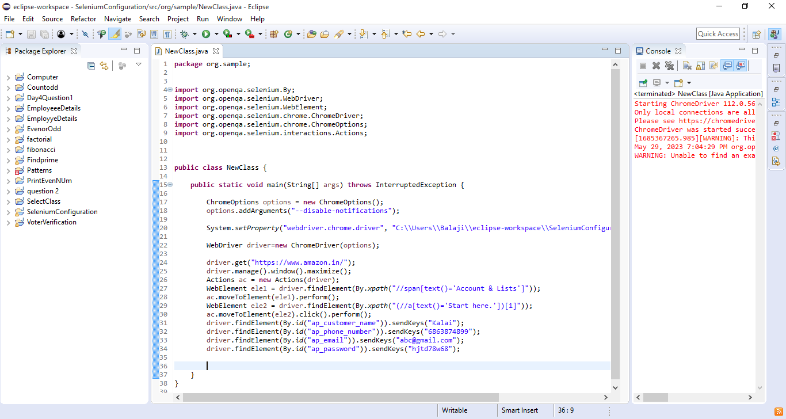

----------

URL : https://www.flipkart.com/

NOTE: womens is mouseover

Click flat slipper

